
HỌC VIỆN CÔNG NGHỆ BƯU CHÍNH VIỄN THÔNG
KHOA CÔNG NGHỆ THÔNG TIN



BÁO CÁO PHÂN TÍCH THIẾT KẾ HỆ THỐNG THÔNG TIN

Đề số 21 – Online department store management
Họ và tên: Tăng Minh Quang
Mã sinh viên: B22DCVT417
Nhóm lớp học: 05
Giảng viên giảng dạy: Đỗ Thị Bích Ngọc

Hà Nội – 2025

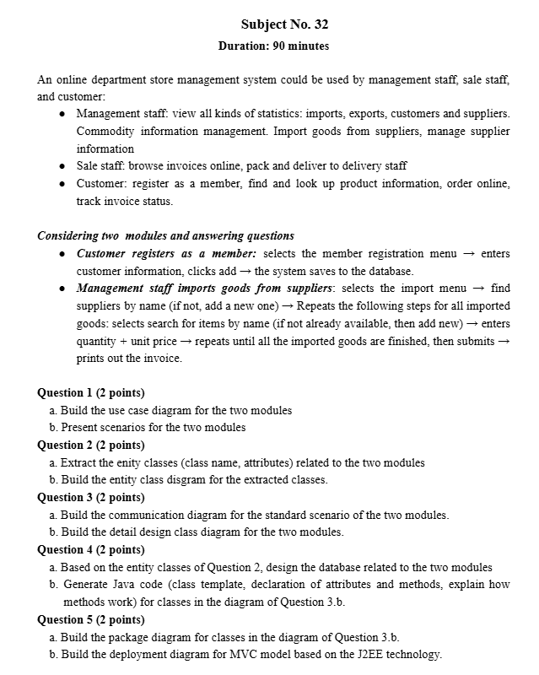

- Specification Phase
- Keyword Table:

TT | Tên tiếng Anh | Giải thích
Nhóm các khái niệm liên quan đến con người
1 | Manager | A person with an account and authority to log into the system and perform allowed functions. For a manager, they can log in to view various statistics (imports, exports, customers, and suppliers), manage merchandise information, import goods from suppliers, and manage supplier information.
2 | Staff | A person with an account and authority to log into the system and perform allowed functions. For sales staff, they can browse online invoices, pack goods, and hand them over to delivery staff.
3 | Customer | A person with an account and authority to log into the system and perform allowed functions. For a customer, they can register as a member, find and look up product information, order online, and track the current status of their invoice.
Nhóm các khái niệm liên quan đến hoạt động của người
4 | Login | The action of a user entering login information to access a system. When the information is confirmed as correct, the user is granted access to the functions or data provided by the system.
5 | Import statistics | The action of a user viewing information that has been collected, recorded, and analyzed related to imported goods. This information includes details about the goods.
6 | Export statistics | The action of a user viewing information that has been collected, recorded, and analyzed related to exported goods. This information includes details about the goods.
7 | Customer statistics | The action of a user viewing information that has been collected, recorded, and analyzed related to customer information. This information includes customer details. The purpose is for the business to understand its customer base and devise optimal strategies and tactics.
8 | Supplier statistics | The action of a user viewing information that has been collected, recorded, and analyzed related to supplier information. This information includes supplier details. The purpose is for the business to understand its suppliers, compare them, and devise optimal strategies and tactics.
9 | Merchandise management | The action of monitoring and coordinating the import, export, storage, and distribution of goods to ensure they are managed efficiently, in the correct quantity and quality, to meet business needs.
10 | Import merchandise from suppliers | The action of ordering and receiving goods from suppliers for use.
11 | Supplier statistics | The action of monitoring and coordinating supplier information, storing and comparing sources of goods to ensure they are managed efficiently, in the correct quantity and quality, to meet business needs.
12 | Approve invoices | The action of checking and approving payment invoices through an online system.
13 | Packaging merchandise | The action of checking and packing goods to be handed over to delivery staff.
14 | Register | The action of providing personal information to create a service account to become a member. After logging in, one can access and use special features reserved for members.
15 | Search | The action of looking up and collecting data related to products based on name, price, or product category to serve shopping or other purposes.
16 | Look up | The action of looking up and collecting detailed data related to products or goods, such as price, origin, stock status, or technical specifications, to serve shopping or other purposes.
17 | Order online | The action of purchasing products or services via the internet through the system, as part of e-commerce.
18 | Track invoice status | The action of checking and updating information about the status of a goods invoice. For example, payment status, processing status, or shipping status.
Nhóm các khái niệm liên quan đến vật, đối tượng vật lý
19 | Merchandise | The items that the system sells and manages. Physical objects can be food, electronics, clothing, or any item the store offers. Product information includes price, origin, and technical specifications.
20 | Invoice | A document certifying a transaction for the purchase or sale of goods or services.
21 | Supplier | A business or individual that provides goods to the store. A supplier can be a partner that supplies the products the store offers. Supplier information includes name, contact information, and the quantity of goods imported.

- Natural Language Description of the System

Step 1: System Purpose
The online department store management system supports the activities of management staff, sale staff, and customers. It allows managing product data, processing import and export transactions, handling online orders, and tracking invoice status.
Step 2: System Scope:
Những người được vào hệ thống và chức năng mỗi người được thực hiện khi vào hệ thống này được quy định như sau:
- System Members
- Log in.
- Log out.
- Change their password.
- Management Staff:
- View statistics: imports, exports, customers, suppliers
- Manage commodity information
- Import goods from suppliers
- Manage supplier information
- Sale Staff:
- Browse customer invoices
- Pack goods and hand them to delivery staff
- Customer
- Customer:
- Register as a member
- Search and look up product information
- Order goods online
- Track invoice status
Bước 3: Business Activity Descriptions:
- Customer registers as a member: A public guest visits the website -> selects the "Register" or "Sign Up" menu -> The system displays the member registration form -> The user enters their required information and clicks the "Add" or "Submit" button -> The system validates the information. If valid, it saves the new customer account to the database -> The system displays a success message and may automatically log the new customer in or direct them to the login page.
- Management staff imports goods from suppliers: The Management staff logs into the system -> selects the "Import Goods" menu -> The system displays the import interface -> The manager searches for a supplier by name -> If the supplier is not found, the system provides an option to "Add New Supplier," where the manager enters the supplier's details and saves -> The manager selects the desired supplier. -> The manager begins adding items to the import invoice. For each item: The manager searches for the item by name -> If the item is not found, the system provides an option to "Add New Item," where the manager enters the new product's details -> The manager enters the quantity and unit price for the selected item -> The manager adds the item to the import list. -> The manager repeats this process for all items in the shipment. -> When all items are added, the manager clicks "Submit" -> The system saves the import invoice, updates the stock quantity for all imported commodities, and generates an invoice record -> The system provides an option to "Print Invoice."
Bước 4: Information Objects to Be Processed:
- People-related information:
- User: username, password, full name, address, date of birth, email, phone
- Staff: username, password, full name, address, date of birth, email, phone, role.
- Management Staff: username, password, full name, address, date of birth, email, phone, role.
.Sale Staff: username, password, full name, address, date of birth, email, phone, role.
- Customer: username, password, full name, address, date of birth, email, phone.
- Thông tin liên quan đến hàng hóa:
- Sản phẩm: mã sản phẩm, tên sản phẩm, giá cả, mô tả, tình trạng trong kho
- Nhà cung cấp: tên, thông tin liên hệ, các mặt hàng cung cấp.
- Thông tin liên quan đến đơn hàng:
- Hóa đơn: số hóa đơn, ngày phát hành, danh sách sản phẩm, tổng giá trị, trạng thái thanh toán.
- Thông tin liên quan đến thống kê:
- Thống kê nhà cung cấp theo lượng hàng nhập.
Bước 5: Relationships Between Objects:
- A supplier can provide many products
- A product may be supplied by multiple suppliers
- An invoice may contain many products
- A customer can place multiple orders
- Management staff may process multiple import invoices
- Sale staff may process multiple customer invoices
- Biểu đồ usecase tổng quan và mô tả usecase:
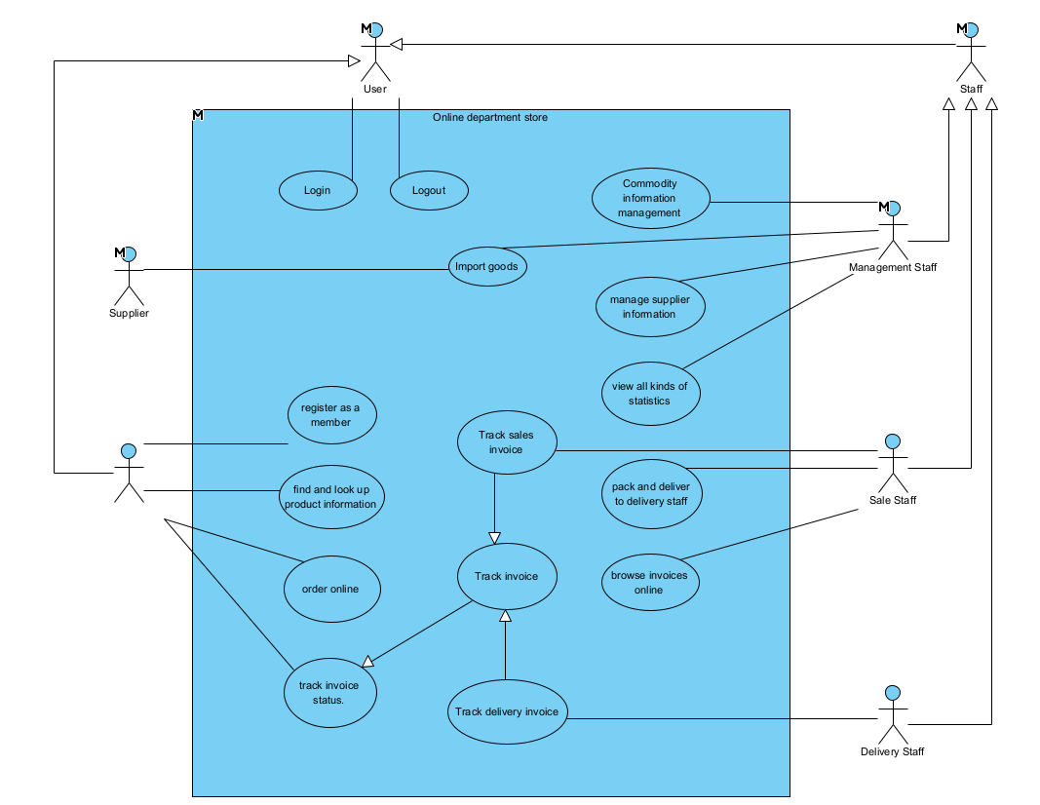
Describing the Use Case Diagram:
- Login – Allows system members to log in
- View Reports/Statistics – Management staff views import/export/customer/supplier statistics
- Manage Information – Management staff manages product and supplier information
- Browse Invoices – Sale staff processes customer invoices
- Register as a Member – Customer creates an account
- Search Products – Customer searches for products
- Look Up Product Information – Customer views detailed product information
- Order Online – Customer places online orders
- Track Invoice Status – Customer tracks invoice status

- DETAILED USE CASE DIAGRAM AND USE CASE DESCRIPTION:
- Customer registers as a member:
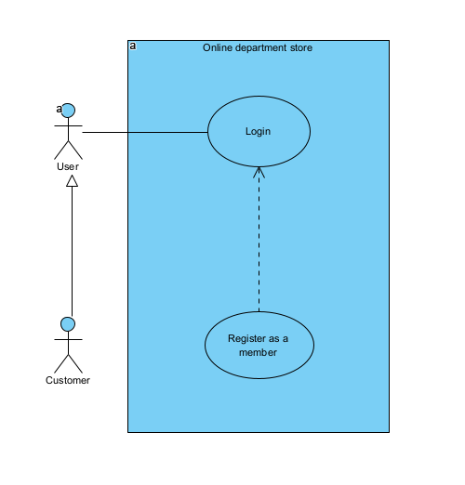
Chức năng tra cứu thông tin hóa đơn có các giao diện tương tác với khách hàng:
- Login: The User enters their credentials (e.g., username and password) to access the system.
- Register as a member: The Customer fills out a registration form with their personal information to create a new account.

- Management staff imports goods from suppliers:
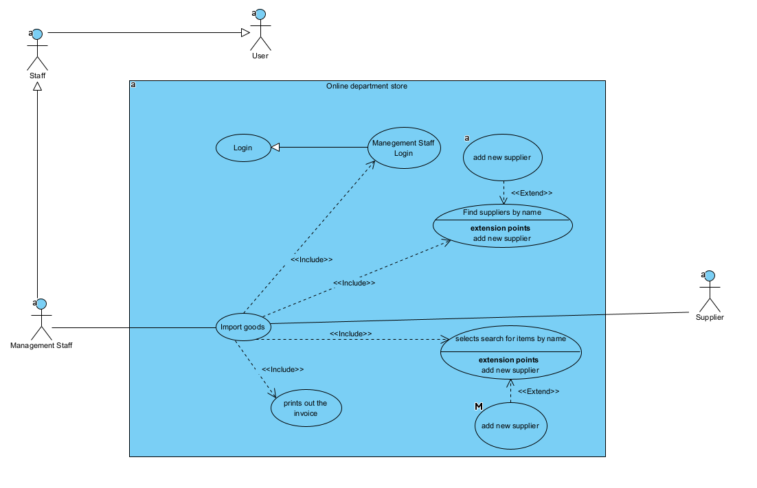
Management staff imports goods from suppliers
- Login: This UC allows a member to log in to the system.
- View all kinds of statistics: This UC allows management staff to view various types of statistics: imports, exports, customers, and suppliers.
- Commodity information management: This UC allows management staff to manage commodity (Goods) information.
- Manage supplier information: This UC allows management staff to manage supplier information.
- Browse invoices online: This UC allows sales staff to browse online invoices from customers.
- Register as a member: This UC allows a customer to register as a system member.
- Find and look up product information: This UC allows a customer to search for and look up detailed information about products.
- Order online: This UC allows a customer to place an order online.
- Track invoice status: This UC allows a customer to track the status of their invoice.
Như vậy, biểu đồ UC chi tiết cho module thống kê nhà cung cấp theo lượng hàng nhập được mô tả:
- Thống kê nhà cung cấp theo lượng hàng nhập 458: UC này cho phép quản lý thống kê nhà cung cấp theo lượng hàng nhập
- Chọn menu xem báo cáo 458: thống nhất với UC Thống kê báo cáo 458 (UC này cho phép quản lý xem các loại thống kê: hàng nhập, hàng xuất, khách hàng và nhà cung cấp)
- Chọn thống kê nhà cung cấp theo lượng hàng nhập 458: UC này cho phép quản lý thống kê được các nhà cung cấp theo lượng hàng nhập
- Chọn thời gian bắt đầu và kết thúc thống kê 458: UC này cho phép quản lý khoanh vùng được khoảng thời gian thống kê
- Xem chi tiết lần nhập hàng của một nhà cung cấp 458: UC này cho phép xem chi tiết lần nhập hàng của một nhà cung cấp
- Xem hóa đơn nhập tương ứng 458: UC này cho phép xem hóa đơn nhập tương ứng của nhà cung cấp đó.

II. Analysys Phase:
- Scenario:
- Module Customer registers as a member

Use case | Customer registers as a member
Actor | Customer
Pre-conditon | The Customer is not already registered in the system.
Post-condition | The Customer is successfully registered as a member.
Scenario | - From the main interface, the Customer selects the 'Register as a member' function.  - The registration interface appears, displaying a customer information form and a 'Register' button.  - The Customer fills in the required information and clicks 'Register'.  - The system validates the data, creates the new member account, and saves it to the database.  - The interface displays a "Registration Successful" message.
Exception | 3a. Customer is already a member (e.g., email or username exists):  - In step 4 of the Main Scenario, the system detects that the customer's information (e.g., email) already exists.  - The system displays an error message: "This account already exists."  - The Use Case terminates or prompts the Customer to log in.

b. Module Management staff imports goods from suppliers.

Use case | Import Goods
Actor | Management Staff, Supplier
Pre-conditon | The Management Staff is successfully logged in and intends to import new items (goods).
Post-condition | New items are successfully imported into the system, an invoice is generated, and stock levels are updated.
Scenario | - After logging in, the Management Staff selects the 'Import Goods' function.  - The 'Import Goods' interface appears. It includes: a 'Find Supplier' button, a 'Find Item' button, labels for supplier information (Name, Address, Phone), a table for the imported items list, and a 'Confirm' button.  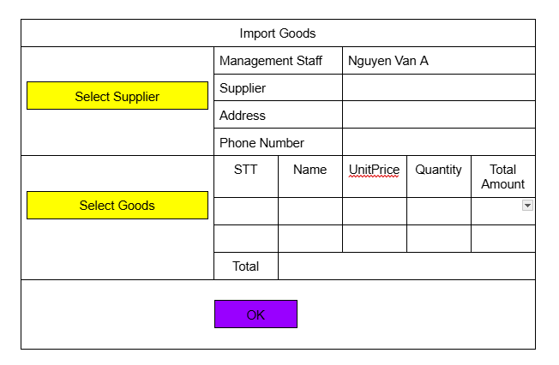  - The staff clicks the 'Find Supplier' button.  - The 'Find Supplier' interface appears. It includes: a 'Back' button, a title label, a search textfield, a 'Search' button, an 'Add New' button, and a list of suppliers.  - The staff enters "nam" into the supplier search field and clicks 'Search'.  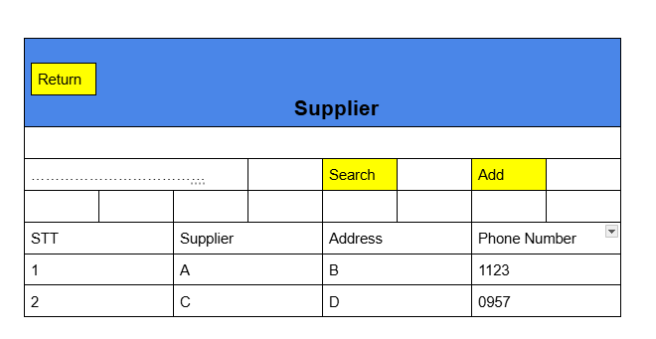  - The system displays a filtered list of suppliers whose names contain "nam".  - The staff selects a supplier (e.g., "A") from the list.  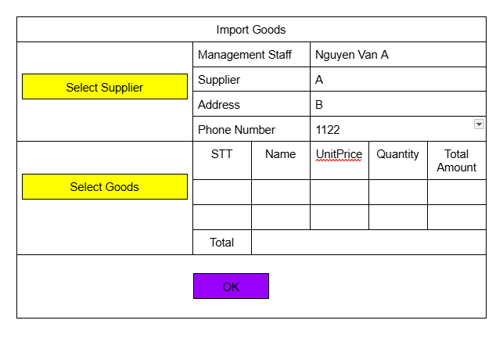  - The system returns to the 'Import Goods' interface, which now displays the selected supplier's information (Name, Address, Phone).  - The staff clicks the 'Find Item' button.  - The 'Goods' interface appears. It includes: a 'Back' button, a title label, a search textfield, a 'Search' button, an 'Add New' button, an 'OK' button, a list of available items, and a table labeled "List of imported items".  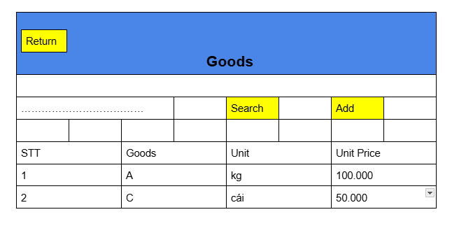  - The staff enters "A" into the item search field and clicks 'Search'.  - The system displays a filtered list of items whose names contain "A".  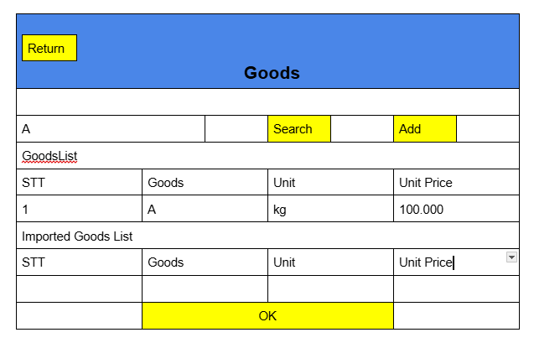  - The staff selects an item (e.g., "A") from the available list.  - The system adds the selected item to the "List of imported items" table on the same screen.  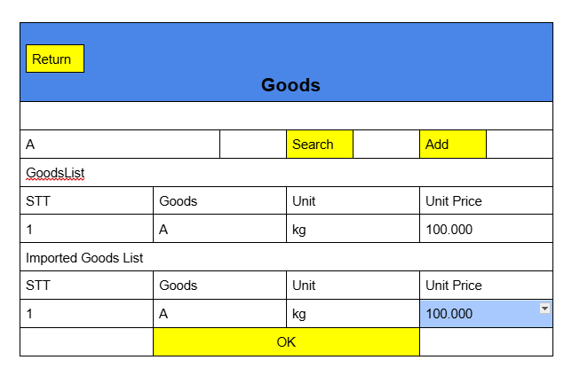  - The staff repeats steps 11-14 until all required items are added to the list.  - The staff enters the Quantity for each item in the "List of imported items" table and then clicks 'OK'.  - The system returns to the 'Import Goods' interface. The table is now populated with the selected items, including Unit, Unit Price, Quantity, and Total Price for each item, and a Grand Total.  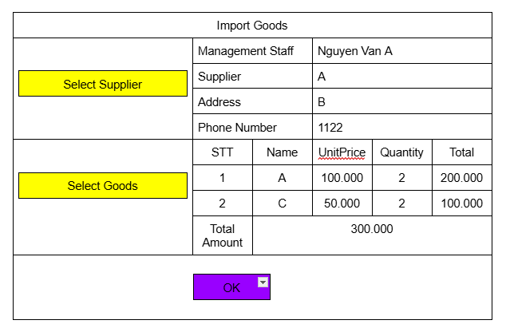  - The staff reviews the completed form and clicks the 'Confirm' button.  - The 'Print Invoice' interface appears, displaying all final details: import date, staff name, supplier information, the complete list of imported items, a 'Cancel' button, and a 'Print Invoice' button.  - The staff verifies the information and clicks 'Print Invoice'.  - The system saves the transaction, updates inventory, and displays a "Import Successful" message.  - The staff gives the printed invoice to the Supplier to process the payment.
Exception | 4a. (At step 5) Staff leaves the supplier search field empty and clicks 'Search':  - 4a.1. The interface displays the complete list of all available suppliers.  5a. (At step 6) No suppliers match the search keyword:  - 5a.1. The staff clicks the 'Add New' (Supplier) button.  - 5a.2. The flow transfers to the "Add New Supplier" Use Case.  10a. (At step 11) Staff leaves the item search field empty and clicks 'Search':  - 10a.1. The interface displays the complete list of all available items.  11a. (At step 12) No items match the search keyword:  - 11a.1. The staff clicks the 'Add New' (Item) button.  - 11a.2. The flow transfers to the "Add New Item" Use Case.  16a. (At step 16) Staff enters a quantity less than 1:  - 16a.1. An error message is displayed (e.g., "Quantity must be at least 1").  - 16a.2. The staff re-enters a valid quantity and clicks 'OK'.  18a. (At step 18) Staff clicks 'Confirm' before selecting a supplier or any items:  - 18a.1. An error message is displayed (e.g., "Please select a supplier and at least one item").  - 18a.2. The staff returns to select the missing information and clicks 'Confirm' again.

2. System Entity Class Diagram
- Entity Class Identification
- People/Roles: Management Staff, Sale Staff, Customer, Delivery Staff
- Core Entities (Objects/Things): Item (Commodity), Invoice, Supplier
- Information/Event Entities: Import Invoice,Export Invoice, Invoice Detail, Import Statistics, Export Statistics, Customer Statistics, Supplier Statistic
- Relationships between Entities:
- An Item can appear on many Import Invoices, and one Import Invoice contains many Items.
- One Category is associated with many Items.
- One Supplier is associated with many Import Invoices.
- One Management Staff member is associated with many Import Invoices.
- An Item can appear on many Sales Invoices, and one Sales Invoice contains many Items.
- One Customer is associated with many Sales Invoices.
- One Sale Staff member is associated with many Sales Invoices.
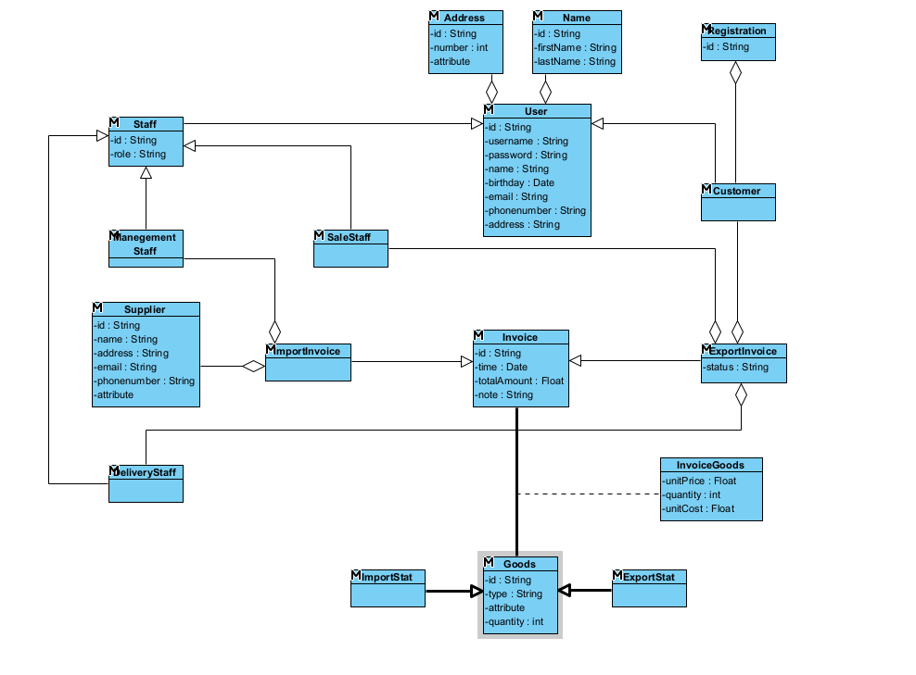

3. Identify Boundary and Control Classes:
- Static Analysis for the “Customer registers as a member” module
- From the main interface Home Page, the customer selects the "Register Member" function Propose the HomePage . It must contain the component:
subRegisterMember: An operation to navigate to the registration page.
- The registration interface appears Propose the RegisterPage . It must contain the components:
Input fields for customer information: inName, inPhoneNumber, inAddress.
A submission control (button): subRegister.
- Entity classes involved in this module are:
User: The parent class containing common attributes like id, username, password, fullName, and phoneNumber.
Customer: The entity class that inherits from User and holds specific customer information . The RegisterPage will interact with a controller to create an instance of this class.
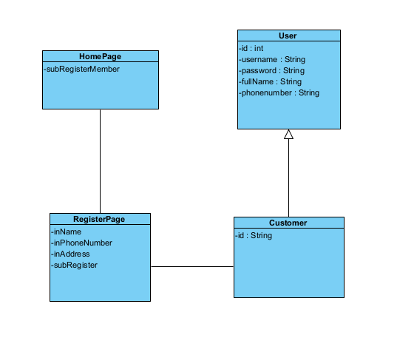
- Static Analysis for the “Management staff imports goods from suppliers” module
- From the main staff interface Propose the HomePageStaff (Boundary Class). It must contain the component:
subImportGoods: An operation (e.g., a button or menu) to initiate the import goods function.
- The main import goods interface appears Propose the ImportPage (Boundary Class). It must contain the components:
subSelectSupplier: Button to open the supplier selection screen.
subSelectGoods: Button to open the goods selection screen.
outSupplierSelected, outSupplierAddress, outSupplierPhoneNumber: Output fields to display the chosen supplier's details.
outImportGoodsList: A table/list to display the selected goods for import.
subConfirm: Button to finalize the import invoice.
- The supplier selection interface appears Propose the SelectSupplierPage . It must contain the components:
inSupplierName: Input field for searching by name.
subSearch: Button to execute the search.
subAddSupplier: Button to open the "Add New Supplier" screen.
inoutSupplierList: A list to display search results and allow selection.
- The add new supplier interface appears Propose the AddSupplierPage . It must contain the components:
Input fields: inName, inAddress, inPhoneNumber.
subAdd: Button to submit the new supplier information.
- The goods selection interface appears Propose the SelectGoodsPage . It must contain the components:
inName: Input field for searching goods by name.
subSearch: Button to execute the search.
subAddGoods: Button to open the "Add New Goods" screen.
inoutImportGoodsList: A list to display available goods and build the import list.
subOk: Button to confirm the selection and return to the main ImportPage.
- The add new goods interface appears Propose the AddGoodsPage (Boundary Class). It must contain the components:
Input fields: inName, inType, inUnit, inUnitPrice.
subAdd: Button to submit the new goods information.
- The print invoice interface appears Propose the PrintInvoicePage. It must contain the components:
Output fields for all invoice details: outDate, outStaff, outSupplier, outAddress, outPhoneNumber, outImportGoodsList.
subPrintInvoice: Button to print the invoice.
subCancel: Button to close the interface.
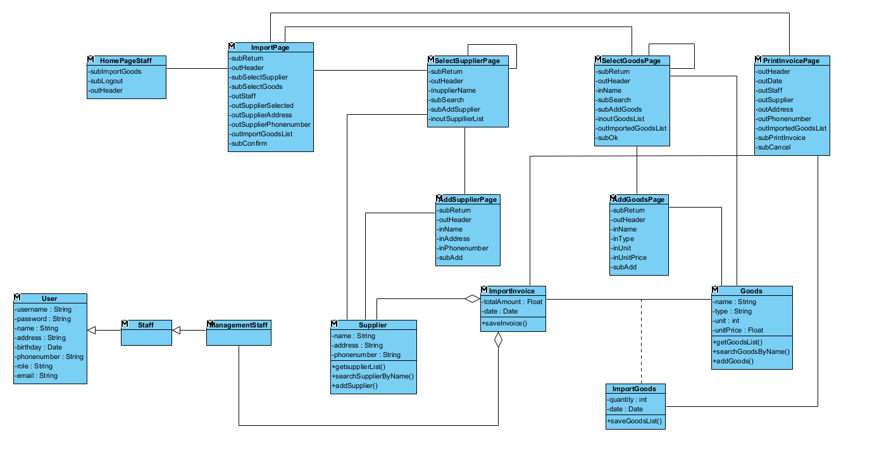
4. Dynamic Analysis:
- Module Customer registers as a member:
Activity Diagram Description:
- From the Begin state, when the customer chooses "Select Register", the system transitions to the Display Customer Home Page interface.
- From the Display Customer Home Page, when the customer "Enters information and clicks register", the system transitions to the Display Register Page interface.
- At the Display Register Page, after processing, the activity flow reaches the End state.
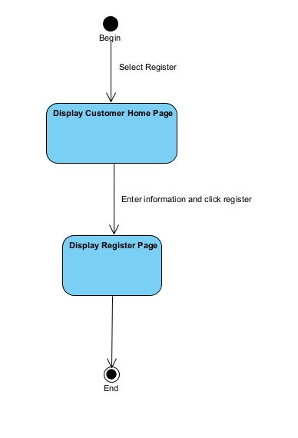
- Scenario v2:
- From the main HomePage interface, the Customer clicks the "Register Member" function .
- The HomePage class calls the RegisterPage class to be displayed.
- The RegisterPage displays the interface to the Customer, including information fields .
- The Customer fills in the form and clicks the subRegister button.
- The RegisterPage collects the data and calls the Customer and User classes, requesting the creation of a new account.
- The system processes the request and saves the information to the Database.
- The Entity class returns a success result to the RegisterPage.
- The RegisterPage displays a "Registration Successful" message to the Customer.
- The Customer closes the interface, ending the Use Case.
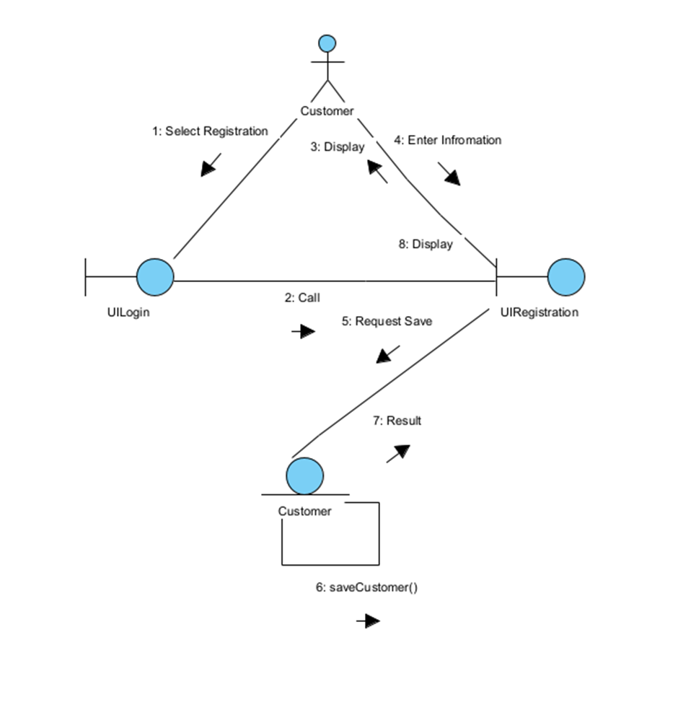
- Sequence Diagram:
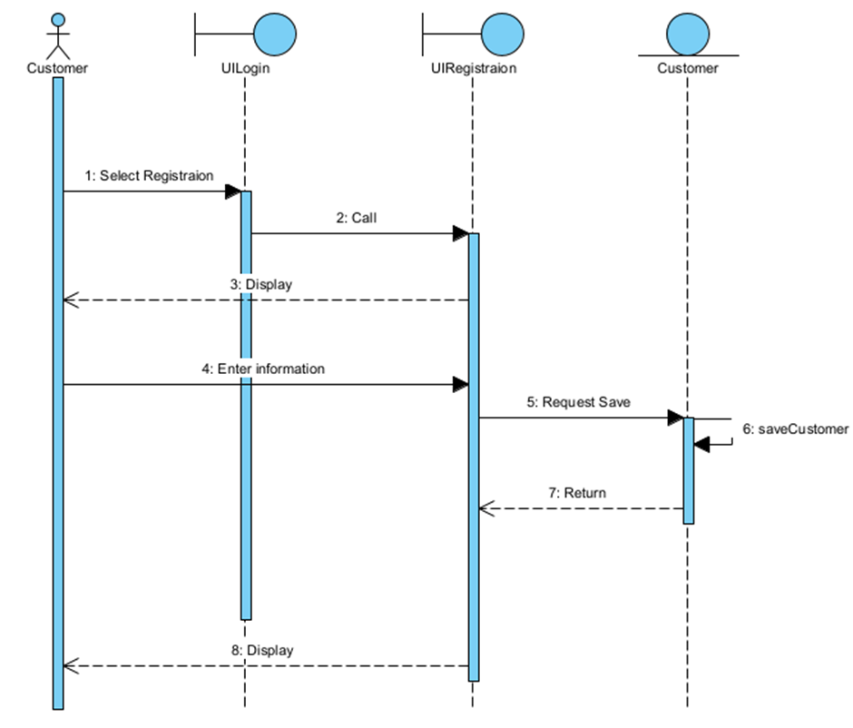
- Module Management staff imports goods from suppliers:
- Activity Diagram Description:
- From the Display Management Home Page, if the ManagementStaff chooses "Select Import Goods", the system transitions to the Display Import Goods Page.
- From the Display Import Goods Page interface:
- If the user clicks "Select Supplier", the system transitions to the Display Select Supplier Page.
- If the user clicks "Select Goods", the system transitions to the Display Select Goods Page.
- If the user clicks "Click Ok" (to confirm the import), the system transitions to the Display Print Invoice Page.
- If the user clicks "Click Cancel", the system transitions back to the Display Management Home Page.
- At the Display Select Supplier Page, after the user "Enters Supplier Name and Clicks OK" and then "Clicks OK, Display Supplier List", the flow returns to the Display Import Goods Page.
- At the Display Select Goods Page, after the user "Enters Goods Name and clicks OK" and then "Clicks OK, Display Goods List", the flow returns to the Display Import Goods Page.
- At the Display Print Invoice Page, when the user clicks "Select Print Invoice, Save in database", the import is finalized and the activity flow reaches the End state.
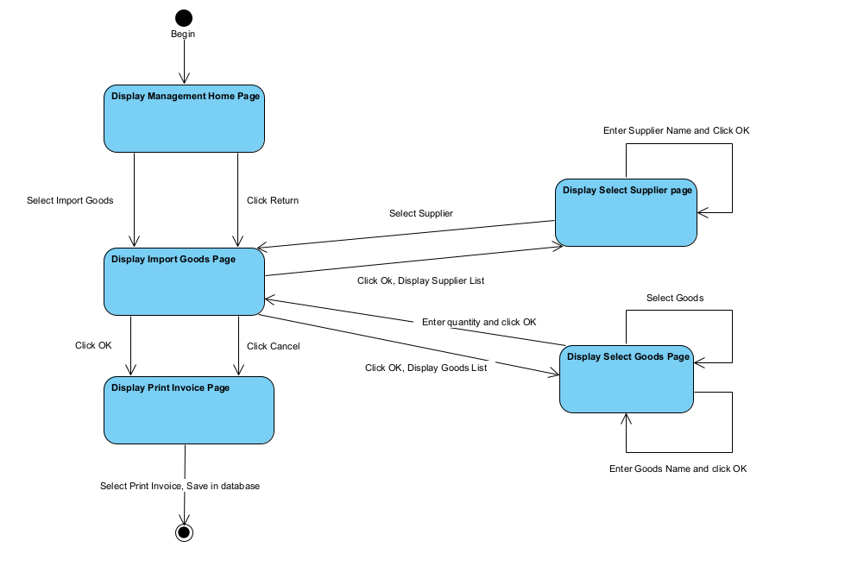
- Scenario v2:
- On the ManagementStaffHomePage, the ManagementStaff (Actor) clicks "Select Import Goods".
- The ManagementStaffHomePage (Boundary) class calls the ImportGoodsPage (Boundary) class to be displayed.
- The ImportGoodsPage interface is displayed.
- The ManagementStaff clicks "Select Supplier".
- ImportGoodsPage calls the SelectSupplierPage (Boundary) class.
- The SelectSupplierPage interface is displayed, prompting the user to search.
- The ManagementStaff enters a supplier name and clicks search.
- SelectSupplierPage calls the Supplier (Entity) class (e.g., searchSupplier(name)).
- The Supplier (Entity) class retrieves the supplier list from the database and returns it to SelectSupplierPage.
- SelectSupplierPage displays the list of suppliers.
- The ManagementStaff selects a supplier from the list and clicks OK.
- SelectSupplierPage returns the selected supplier's data to ImportGoodsPage.
- ImportGoodsPage updates its interface to show the selected supplier.
- The ManagementStaff then clicks "Select Goods".
- ImportGoodsPage calls the SelectGoodsPage (Boundary) class.
- The SelectGoodsPage interface is displayed, prompting the user to search for goods.
- The ManagementStaff repeatedly searches for goods (calling Goods.searchGoods(name)), selects an item, and enters the quantity.
- After adding all items to the list, the ManagementStaff clicks "OK" on the SelectGoodsPage.
- SelectGoodsPage returns the list of selected goods (as ImportGoods objects) to ImportGoodsPage.
- ImportGoodsPage updates its interface to show the complete list of items to be imported.
- The ManagementStaff reviews the list and clicks "Confirm" (Click OK).
- ImportGoodsPage calls the PrintInvoicePage (Boundary) class, passing the supplier and goods list.
- PrintInvoicePage calls the ImportInvoice (Entity) class to create the invoice.
- ImportInvoice (or its DAO) calls saveInvoice() to save the main invoice details and ImportGoods.saveImportGoods() to save each line item to the database.
- The entity classes return a success message to PrintInvoicePage.
- PrintInvoicePage displays the final, generated invoice details to the ManagementStaff.
- The ManagementStaff reviews the invoice and clicks "Print" or "Close", ending the Use Case.
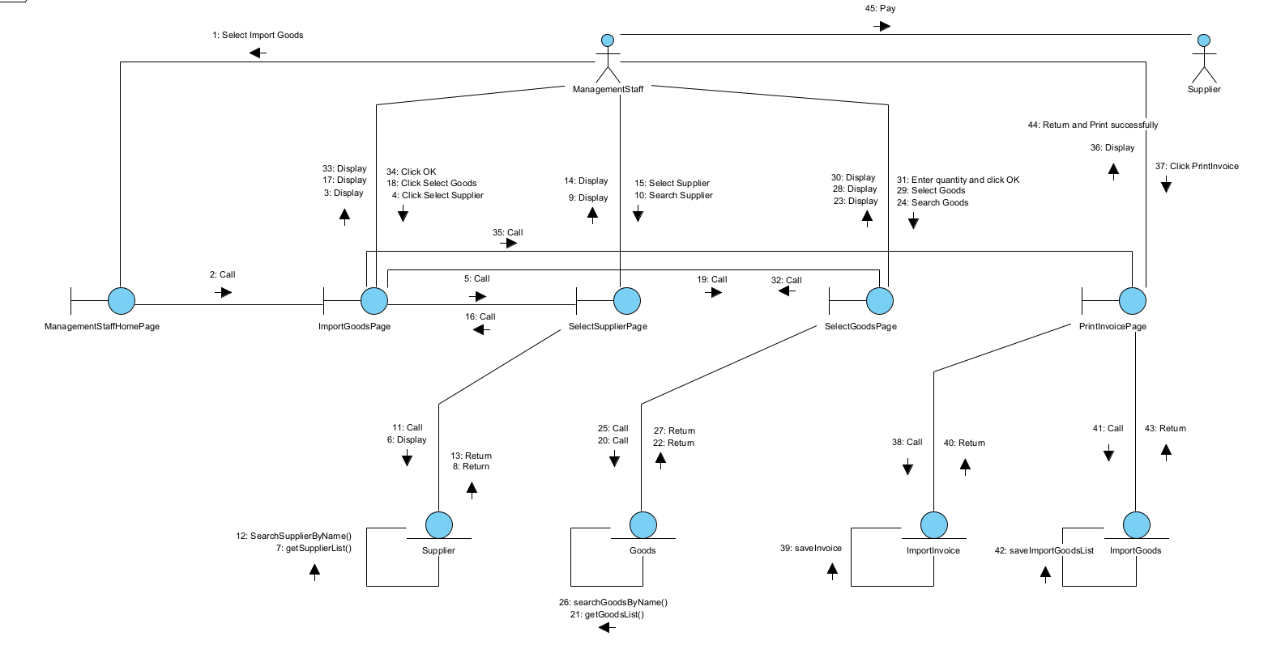
- Sequence Diagram:
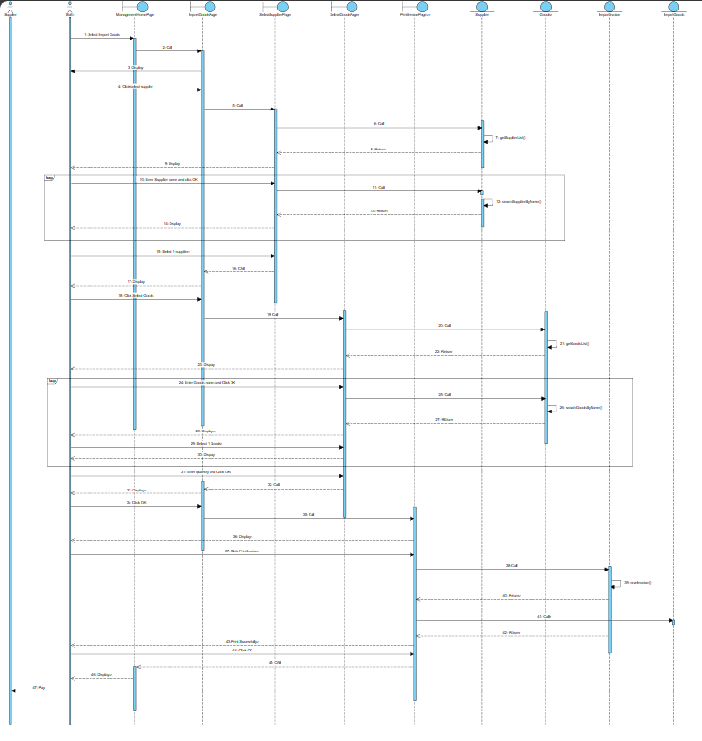

III. Design Phase
- Entity Class
- Add field id and attribute extensions in the style of the Java language installer
- Relationship between ImportInvoice - Goods => ImportGoods includes ImportInvoice and Goods
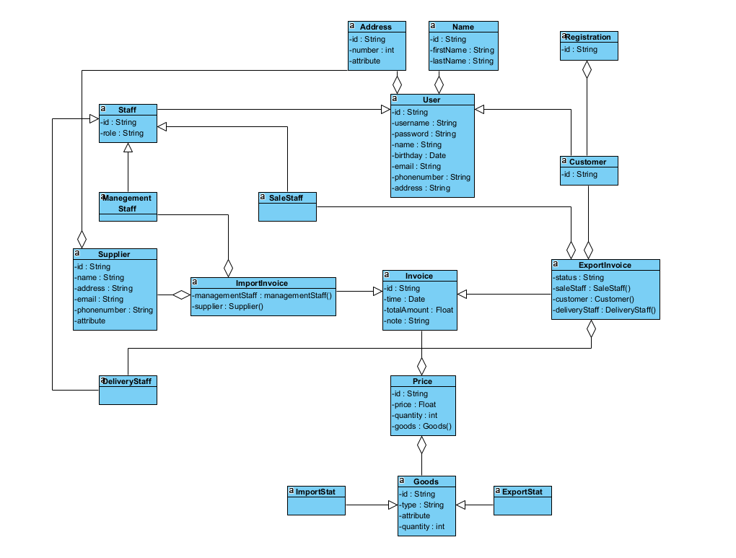
- Database Design:
- Each entity class proposes a corresponding table:
- User => tblUser
- Name => tblName
- Address => tblAddress
- Staff => tblStaff
- ManagementStaff => tblManagementStaff
- SaleStaff => tblSaleStaff
- DeliveryStaff => tblDeliveryStaff
- Customer => tblCustomer
- Registration => tblRegister
- Supplier => tblSupplier
- Goods => tblGoods
- Invoice and ImportInvoice => tblImportInvoice
- Invoice and ExportInvoice => tblExportInvoice
- Price is resolved into two tables => tblImportPrice and tblExportPrice
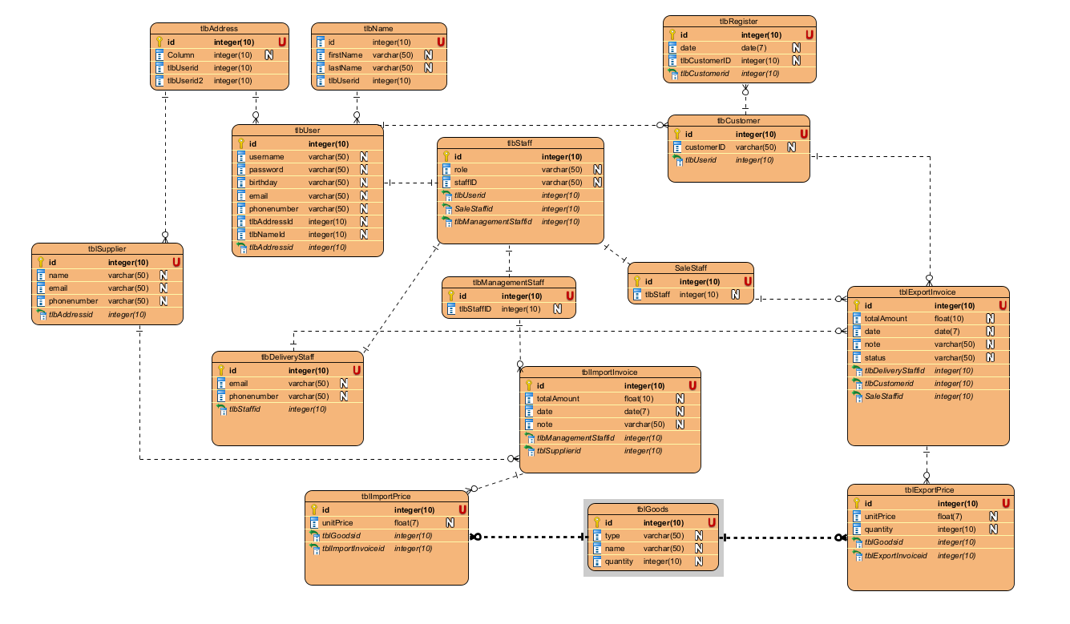

- Design Class Diagram
- Module Customer registers as a member
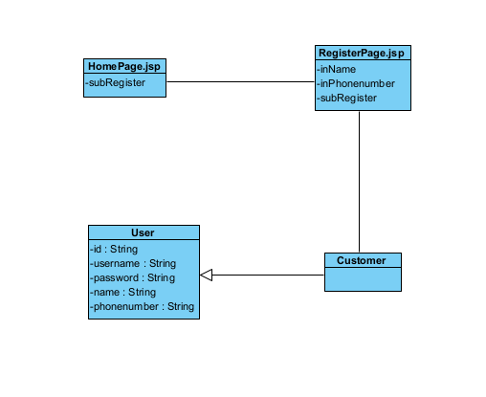
- Module Management staff imports goods from suppliers
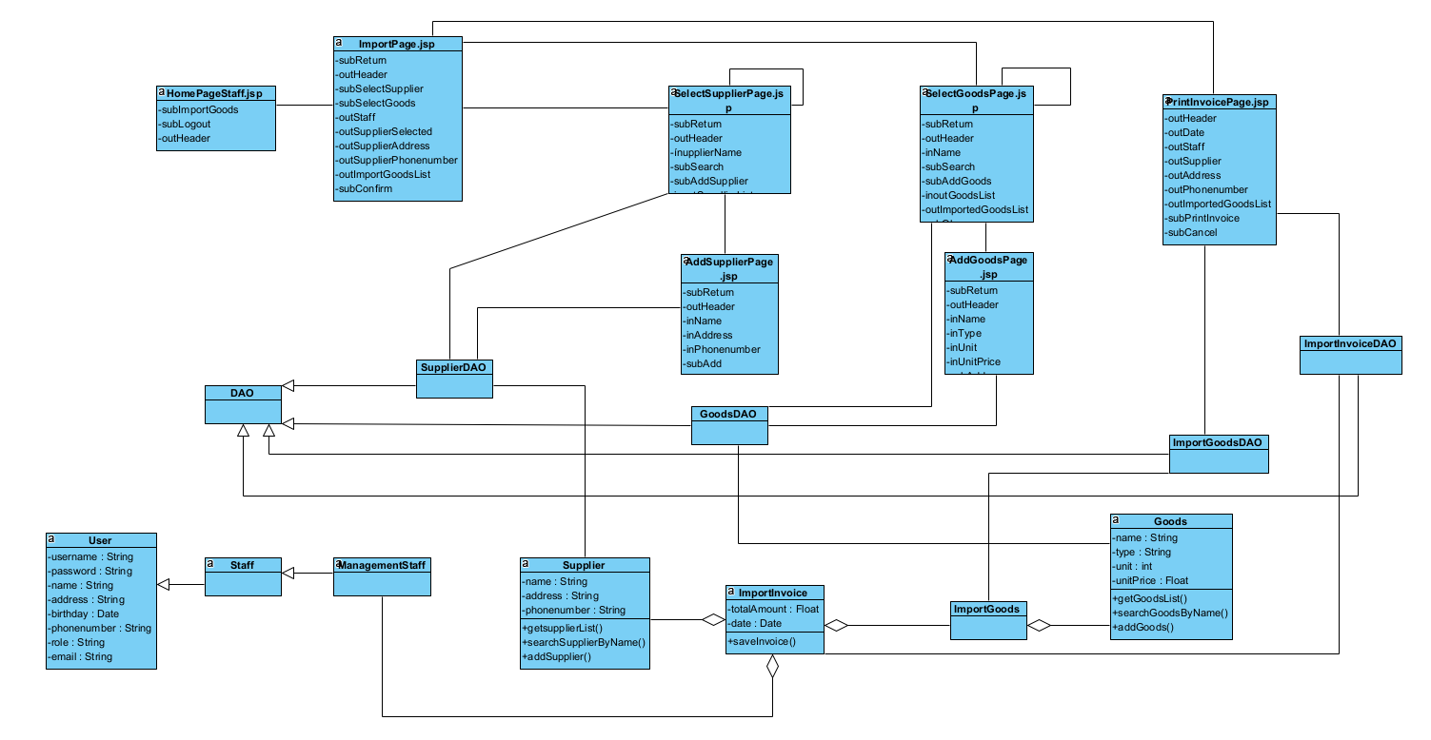

4. Design UI
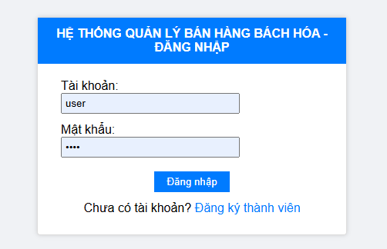
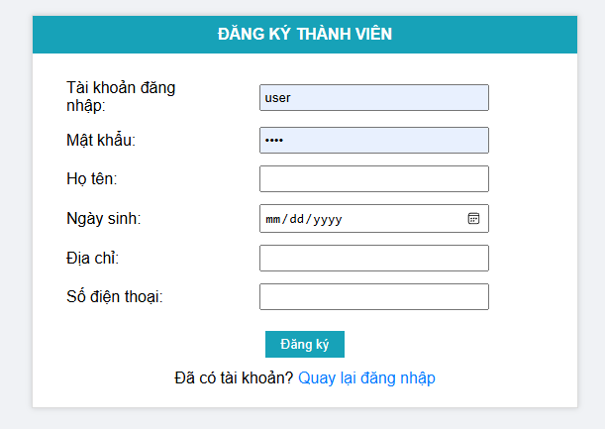
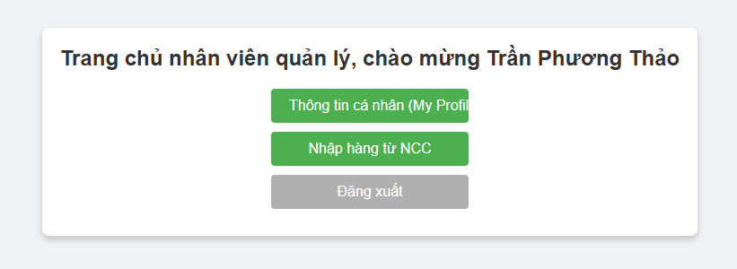
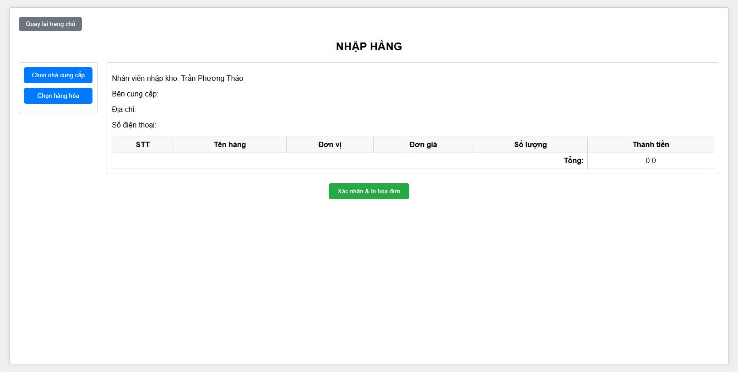
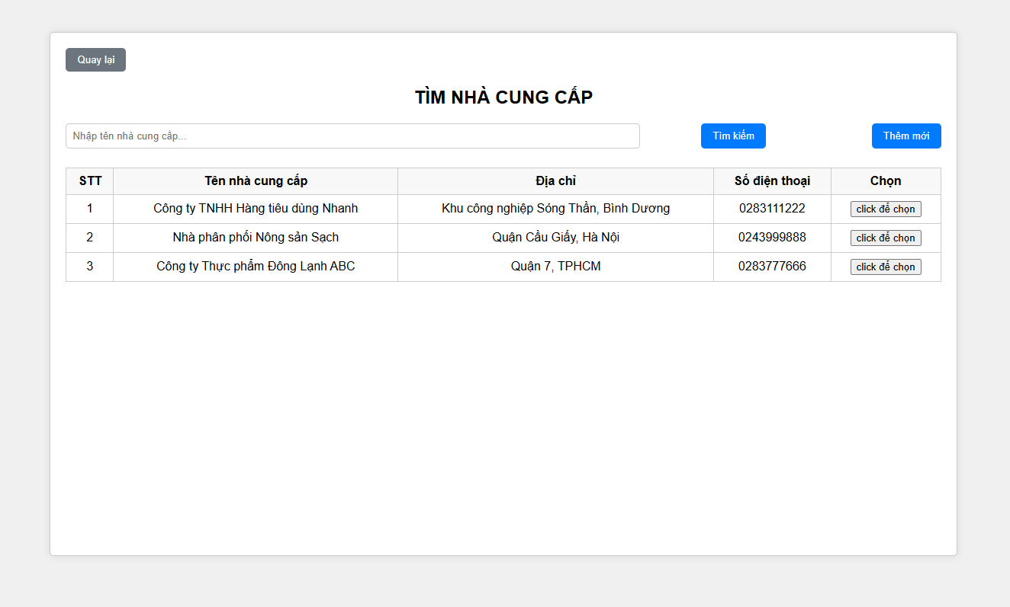
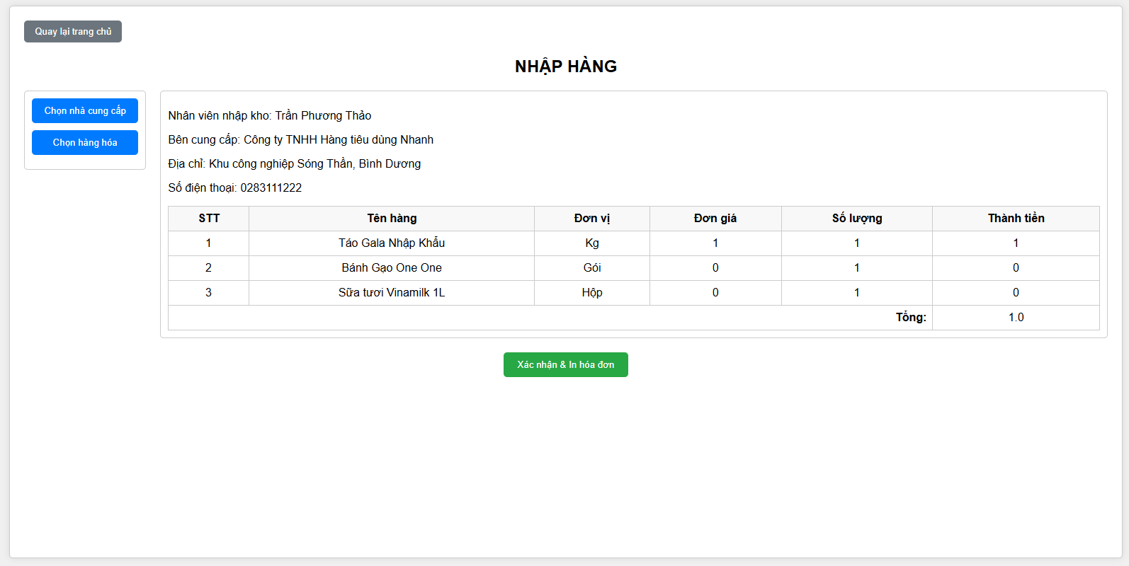
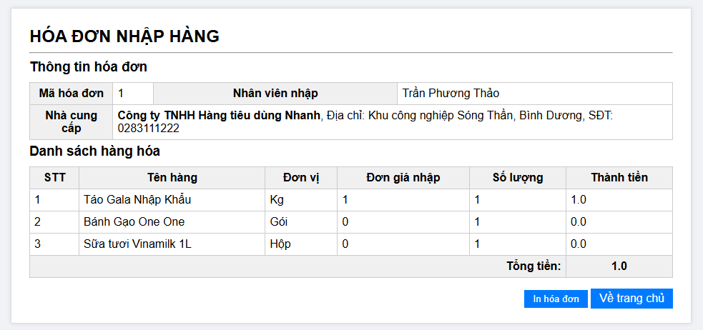
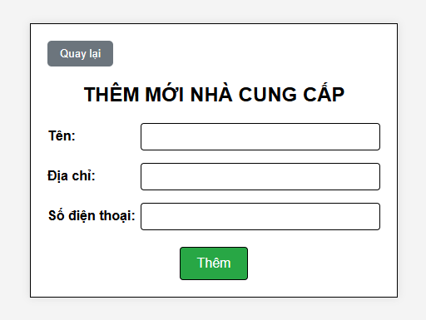
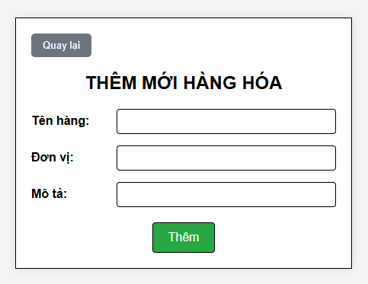

5. Design Activity Diagram
- Module Customer registers as a member
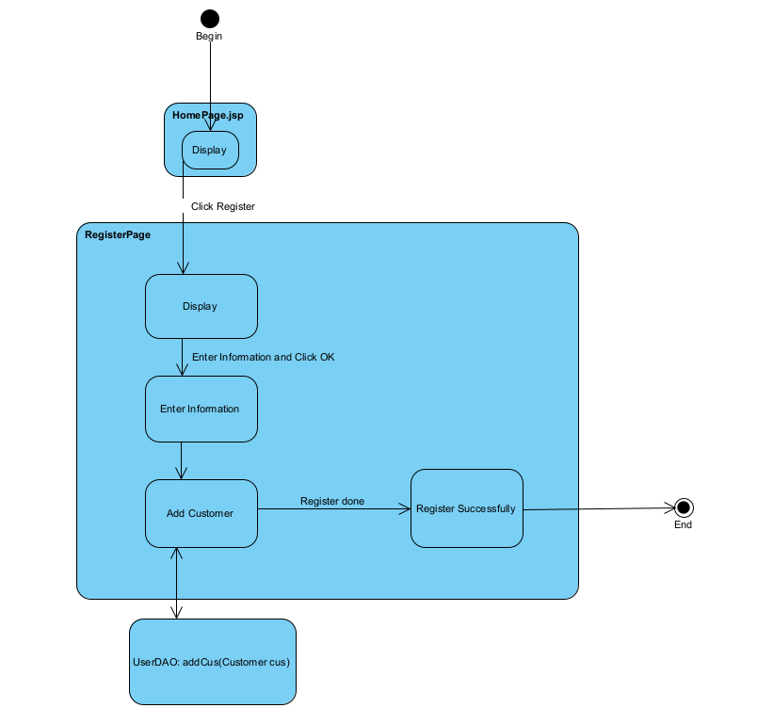
- Module Management staff imports goods from suppliers
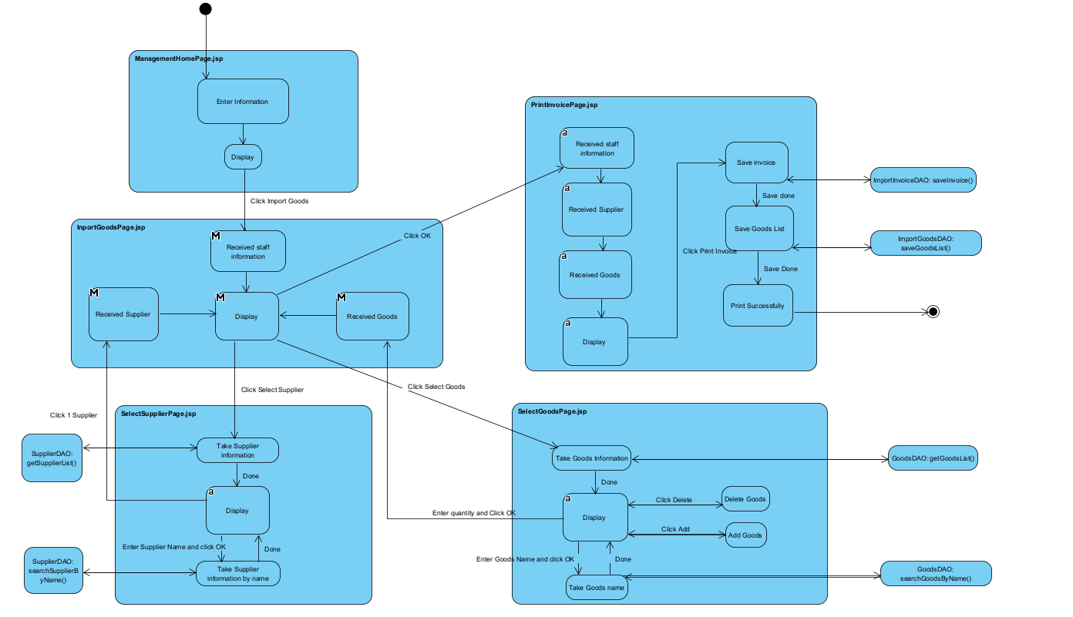

6. Design Sequence Diagram
- Module Customer registers as a member
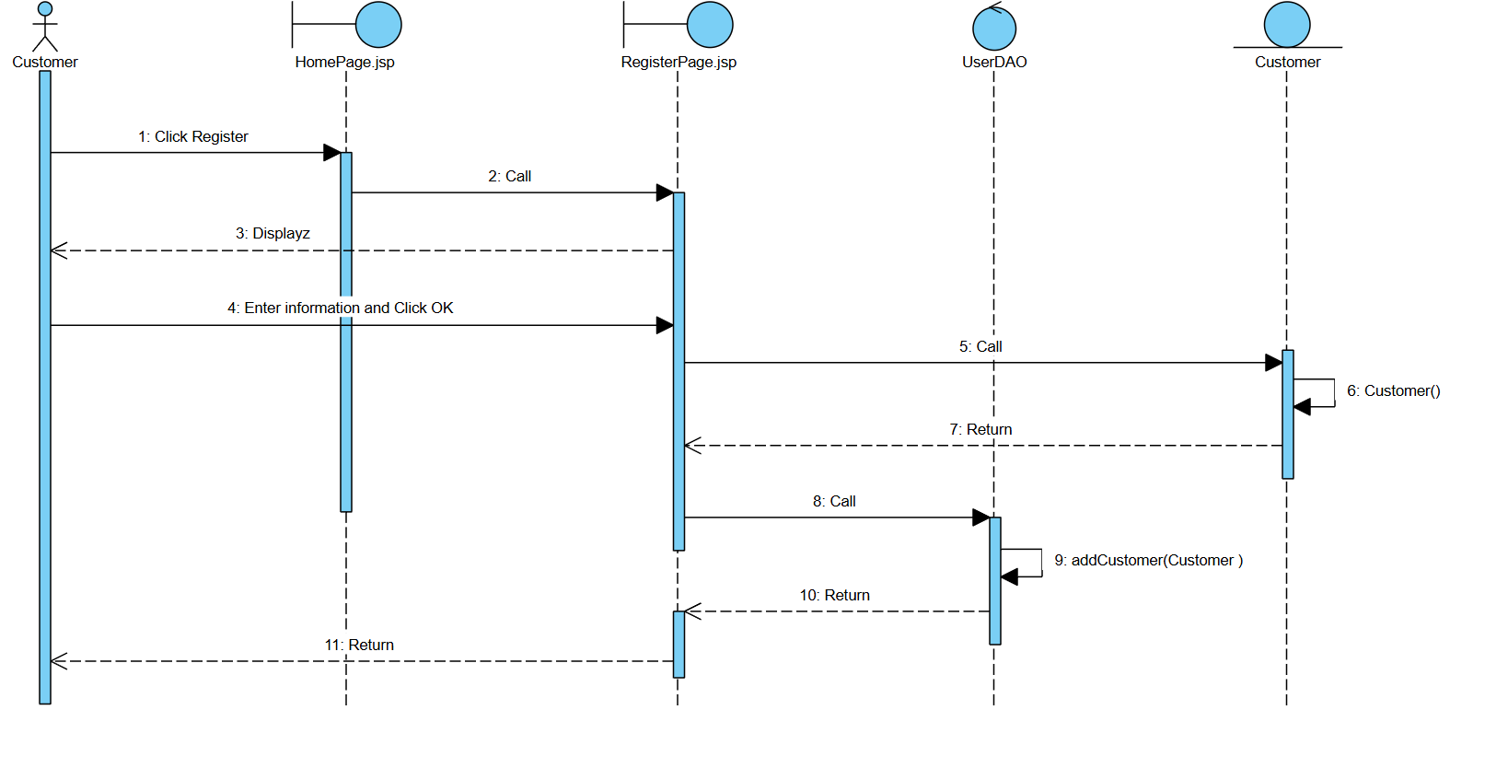
- Module Management staff imports goods from suppliers
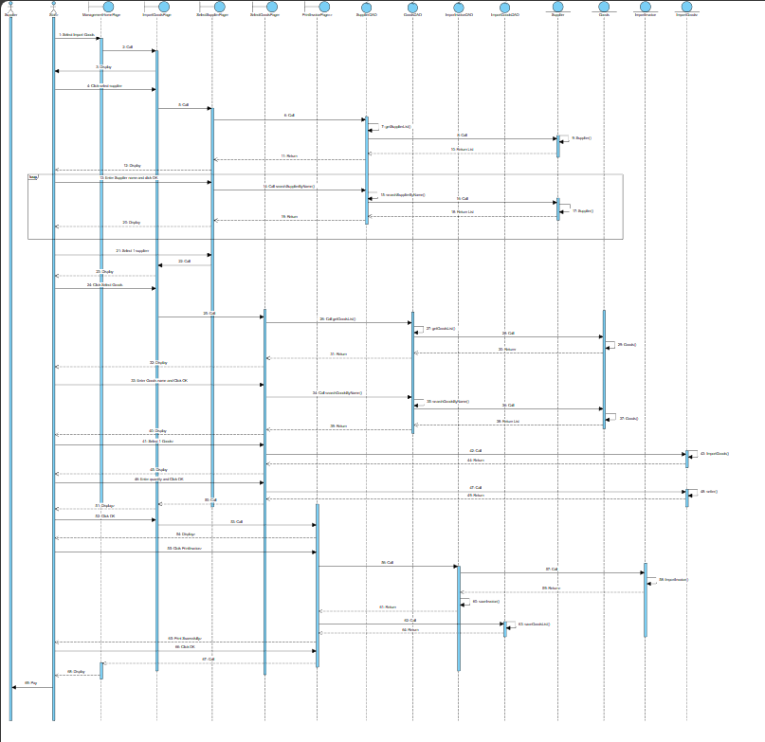

Link Source Code: https://github.com/whyalwaysme2x/PTTK.git

